Credit Task 2

Swin Adventure

Iteration 4&5

# Related Learning Outcomes

# ULO1 – Explain the OO Principles

# ULO2 – Use OO Language and Library

The task demonstrates how to create and implement interfaces in C# programming.

# ULO3 – Design, Develop and Test using an IDE

# ULO4 – Communicate using UML Diagrams

# ULO5 – Describe Elements of Good OO Design

IDE screenshots:

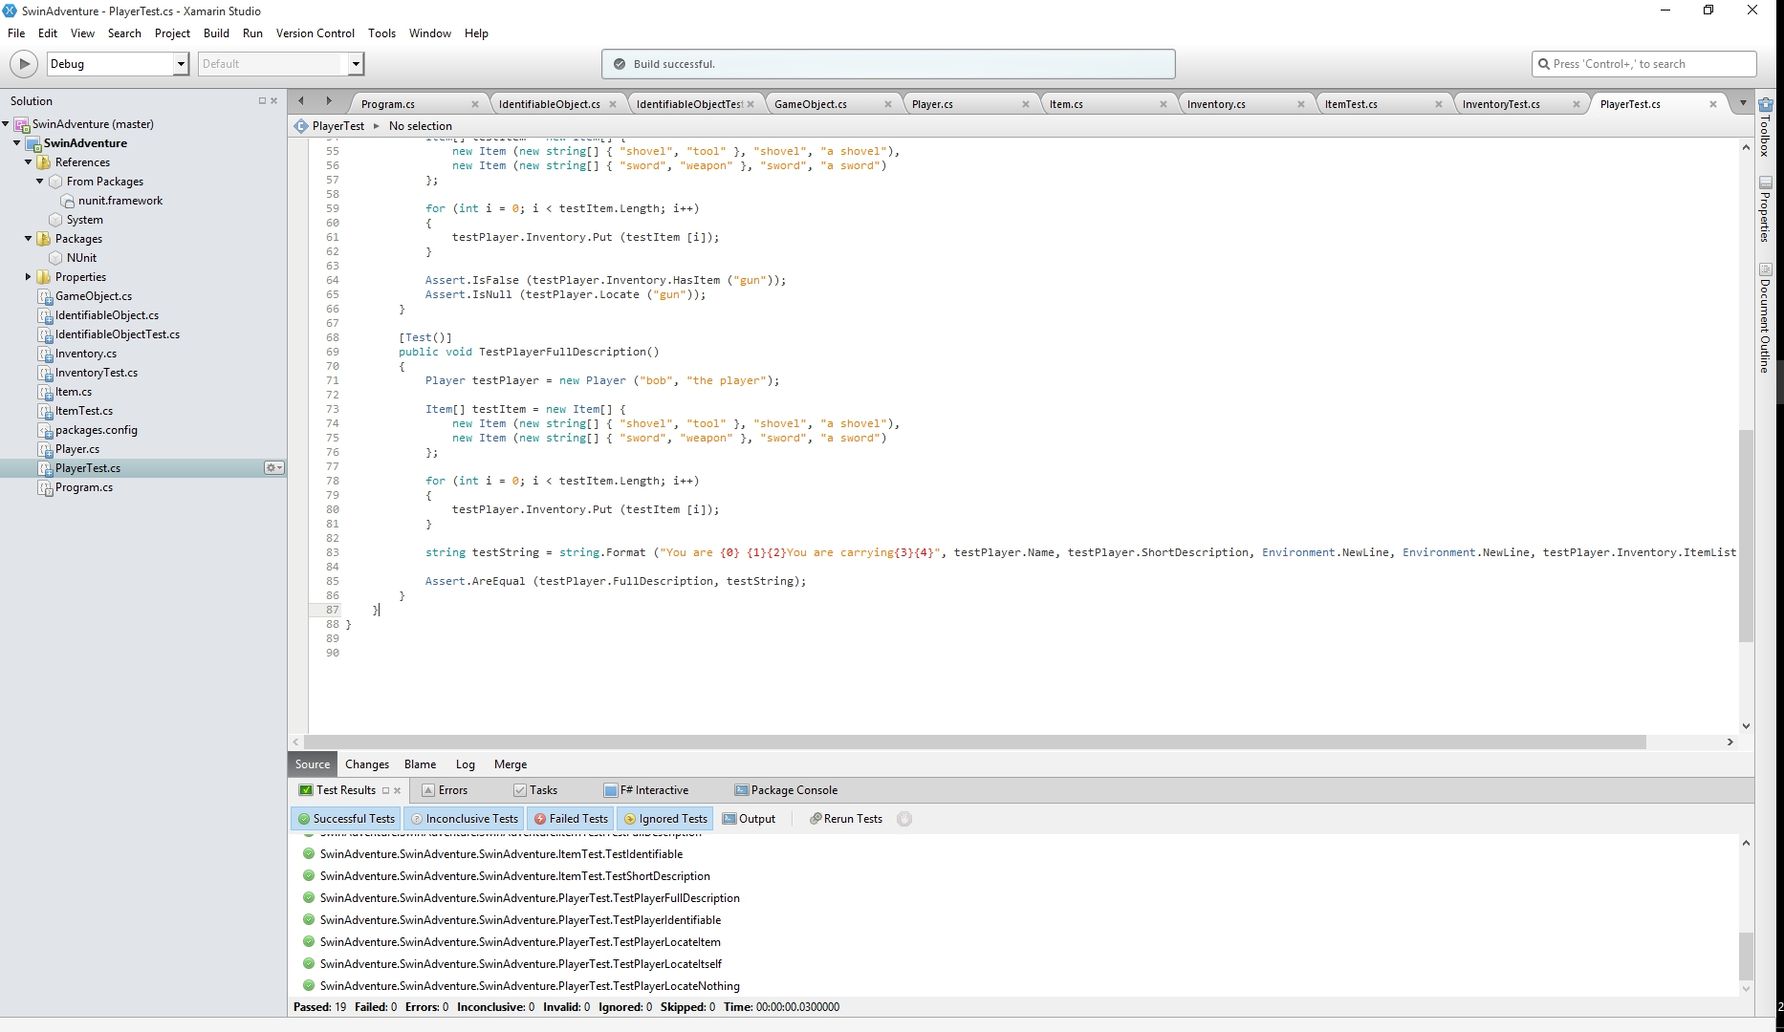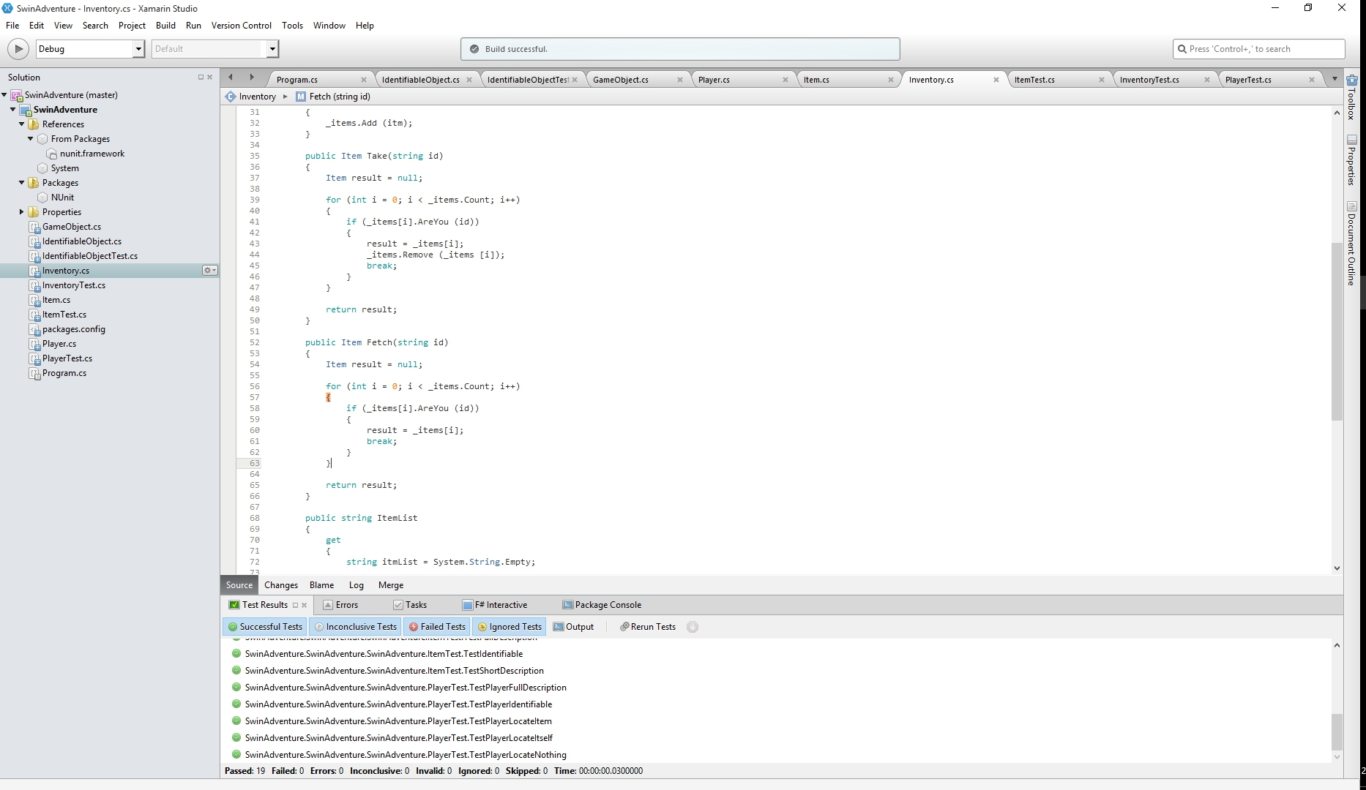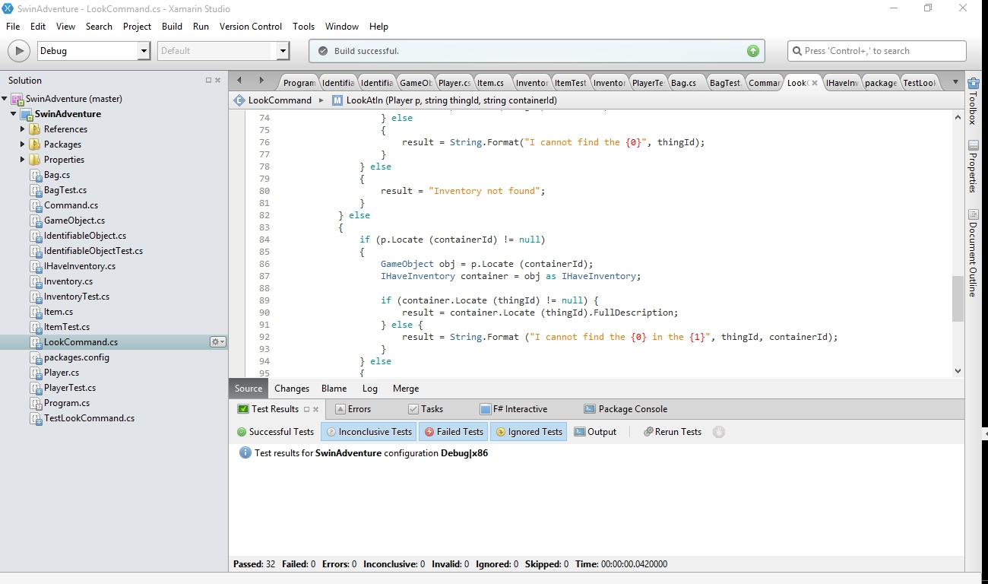

Early Look command implementation:

